How to Schedule and automate an R script in Windows 7 for absolute beginners.

1. Locate the install directory for R
2. Find the path up to the “bin” folder. There should be 2 .exe files in this folder. R.exe and RScript.exe (Ex. C:\Program Files\R\R-3.0.2\bin)
3. Copy and past your R script you want to automate in this folder. Make sure this is a .R and not a .txt file. (My example is test.R)

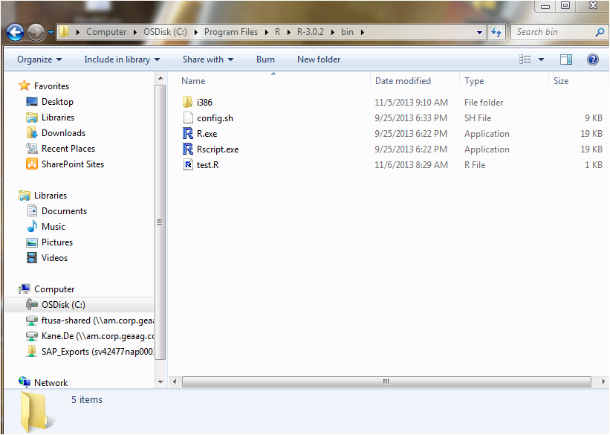

Here is the R code text from the test.R file.

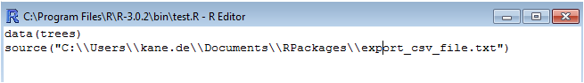

There are 2 pieces of info contained in this Rscript to show proof of concept and also the ability to create complex tasks:

1. Connecting to a standard dataset included in the base R build: trees
2. Running another predefined script “export_csv_file.txt” located as a text file. Note that the full directory is spelled out here with double \\ instead of the single slash. A breakdown of this second R script is shown below:

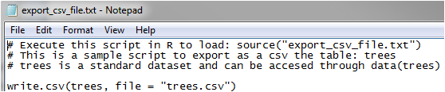

1. We now need to create a batch file so that the scheduled task manager will run properly.
2. Open up Notepad and type the following into the file:

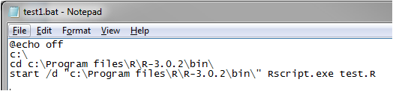

1. Save this file as test1.bat (change the extension to .bat)

We are now ready to schedule the R script task to run on a predefined schedule. See next section for details.

Windows Schedule Task Manager Setup

1. Run the schedule task manager in Windows. (All Programs->Accessories->System Tools->Task Scheduler)
2. Create a task (not the basic task)

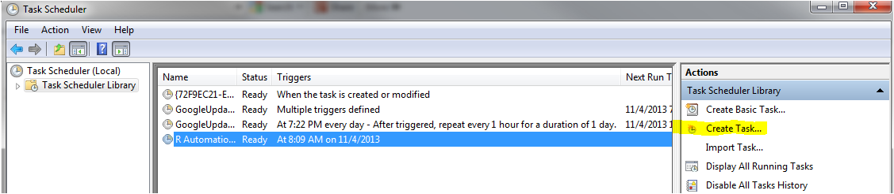

1. Make sure that the following settings are configured below. (“Run with Highest privileges” will ensure that the administrator privileges will be turned on when running the job. Also, if the user login does not have admin rights then this approach will not work)

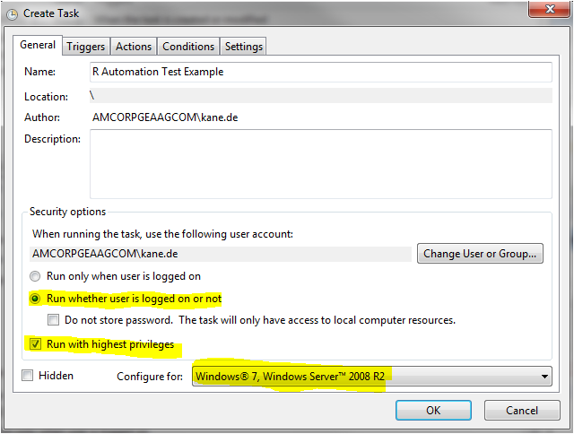

1. Click on the Trigger Tab and create a new trigger. (This example will run daily at 8:00 am but you can change this to whatever you need)

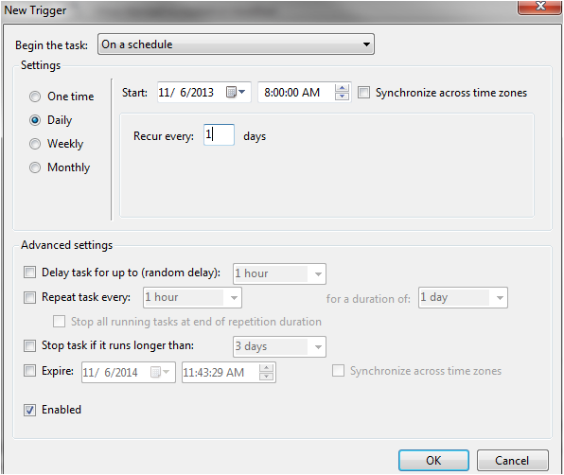

1. Click on the Actions Tab and select “new”
2. In the Program/Script space, type the full directory to the .bat file we created earlier.

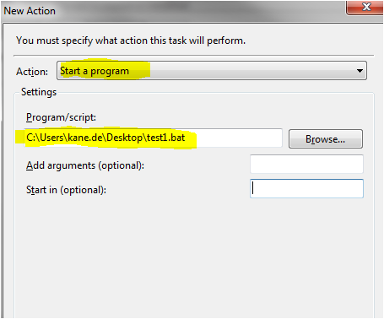

Let’s manually run the task we created to ensure that it works.

1. Right Click on the task and select “run”

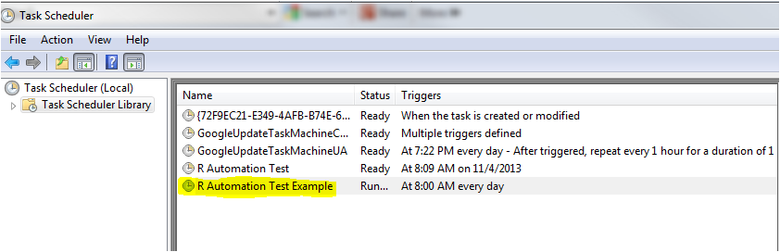

1. Goto the source directory where “bin” is located (Ex. C:\Program Files\R\R-3.0.2\bin) and you should see the result of this process which is the trees.csv file.

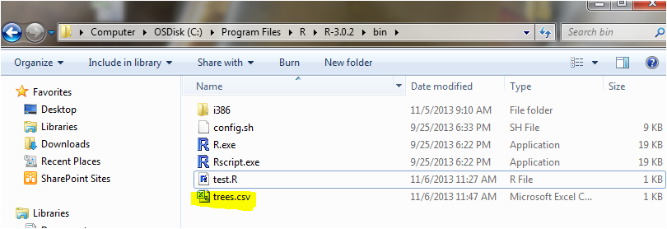

We are all set now and this script will run as regular as a German train schedule moving forward.